Workshop Final Report – Matan Moalem
Part 1: General information
Three collab notebooks:
IsolationForest.ipynb - Colab
XGBoost-LMD.ipynb - Colab
AnomalyDetection_with_AE-LMD.ipynb - Colab

I chose to detect Lateral Movement.
Lateral movement refers to a group of methods cyber criminals use to explore a network after initial access, to find vulnerabilities, escalate access privileges, and reach their ultimate target.
Few characteristics of such attacks:
- Observation:
Attacker observes, explores and maps the network, its users, and devices.
This can be reflected in Sysmon logs with EventIDs types and their associated features.
For example:
EventID 1 (Process Creation) can be useful for spotting a creation of scanning tools (ProcessID).
EventID 3 (Network connection) can be useful for detecting port scans or connecting to unusual ports.
- Privilege Escalation:
Illegally obtaining credentials by tricking users into sharing such information by using phishing attacks.
This can be reflected in Sysmon logs with EventID, for example:
EventID 1 that is associated with malicious process.
EventID 10 (ProcessAccess to a resource managed by the operating system) can be associate with malicious activity (like opening lsass.exe).
EventID 13 (is for Value Set) that can be associated with changes in RDP connection that can be malicious.
- Gaining Access:
Performing internal access then bypassing security controls to reach successive hosts can be repeated until the target data has been found and exfiltrated.
EventID 17 (Pipe Creation) can indicate pipe names that are strong lateral movement indicators.
EventID 23 (File Delete) can be seen after attackers deleting tools/logs of lateral movement.
To be clear, EventID is not an indication for lateral movement, but also its associated features: For example, with process creation (EventID 1), we can see a creation of a normal process, while another log entry can indicate a creation of a malicious process.
Part 2: The dataset and feature extraction:
The data set that is used in the project is LMD-2023.
The LMD-2023 dataset was generated in a Microsoft Windows Domain testbed composed of both virtual and physical machines, realistically emulating a typical SOHO (Small Office/Home Office) environment. The collection process produced EVTX log files, which were later converted into readable CSV format using the ETCExp tool (that can be found in this link). This tool is optimized for efficiently processing large EVTX files.
Data set structure:
The dataset includes three labels: Normal, EoRS (Elevation of Remote Session), and EoHT (Elevation of Host Tools). The latter two classes together represent 15 lateral movement (LM) techniques. All events are provided in a single combined file containing approximately 1.75 million records, where 92% are labeled as Normal (0) and the remaining 8% as abnormal (EoRS = 1 or EoHT = 2).
The features:
SHAP explanation is made for the 9 features which are used in the paper combined with all the other numeric features. However, some numeric features are not included due to having the same value all over the log records or due to delivering the same meaning as other features or due to irrelevance to the detection task.
For example Task feature is identical to EventID, UTCtime has the same meaning as SystemTime, Channel feature has the same value all over the log records and Version2 just indicates the event log format version.
After further consideration, time-based features were excluded from the analysis. When they were included, the model achieved nearly perfect performance (Precision ≈ 1.0, other metrics ≈ 0.99). However, these results were misleading, as the abnormal events in the dataset were concentrated within specific time windows. This allowed the model to rely on temporal patterns rather than learning the underlying behavioral characteristics of lateral movement activity. Since the objective was to detect abnormal behavior based on relevant event features rather than the time at which it occurred, removing time-based features yielded more realistic results. While time can provide useful context (unusual activity during off work hours), in this dataset it introduced bias rather than insight.
The features that weren't introduced in the last report:
ThreadID
Unique identification number of the thread that triggered the event.
Helps correlate specific suspicious actions to a thread. Attackers may spawn abnormal threads to inject code or run stealthy operations.
SourcePort
Port number used by the source system to initiate communication.
Useful for spotting unusual or high-numbered ephemeral ports commonly used in lateral connections or credential dumping over SMB/RDP.
Level
Severity category of the event (Information, Warning, Error, Critical, Success Audit, Failure Audit).
Can filter out benign activity vs. suspicious anomalies. For example, repeated “Failure Audit” on logins suggests brute-force or privilege escalation attempts.
TerminalSessionId
Identifier of the terminal session in which the event occurred.
Helps detect attackers moving laterally via remote sessions (RDP/SSH).
QueryStatus
Status returned when querying system or process information.
Failed queries or errors could indicate attempts to enumerate system info unsuccessfully, which is common during reconnaissance phases.
ParentProcessId
Process ID of the parent process that spawned the current process.
Crucial for detecting abnormal process trees. Example: explorer.exe spawning powershell.exe with encoded commands often indicates lateral movement activity.
SourceThreadId
ID of the thread from which the event originated.
Helps correlate threads to suspicious parent processes. Attackers may inject malicious code into legitimate processes via threads.
TargetProcessId
Process ID of the process being targeted by the event.
Detects process injection or privilege escalation attempts when a low-privileged process targets a system-critical process.
NewThreadId
ID assigned to a newly created thread.
Monitoring thread creation can expose malicious behavior (e.g., attackers creating new threads inside lsass.exe to dump credentials).
Eventually after SHAP explanation I took the 10 features with the highest SHAP values (means they affect decisions the most)
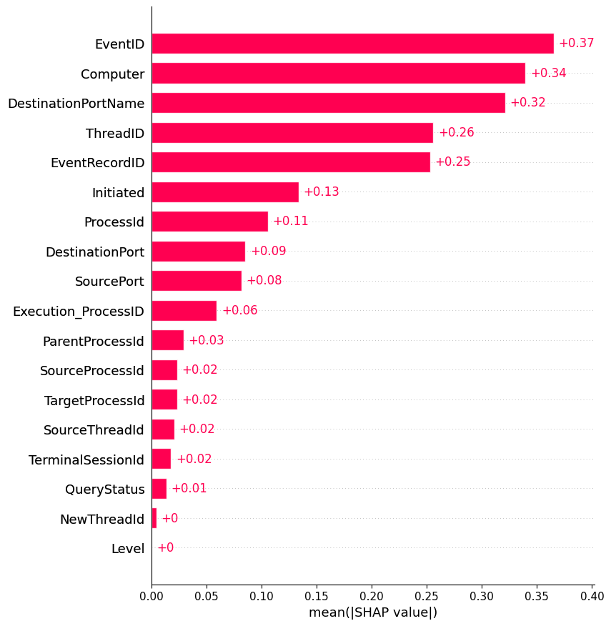
The SHAP values plot:
The SHAP explanation was done with
IsolationForest ML technique, and was based
on these 2 tutorials:
link1 link2.

Part 3: The ML models
IsolationForest:
Isolation Forest is an unsupervised anomaly detection algorithm that works by randomly selecting features and split values to isolate data points. Since anomalies are rare and different from normal points, they are easier to isolate and tend to appear closer to the root of the tree. The algorithm builds an ensemble of such trees, and the average path length is used as an anomaly score: shorter paths indicate higher likelihood of being an anomaly.
In this technique I use GridSearchCV search function in scikit-learn to find the best parameters to train the model.
GridSearchCV exhaustively considers all parameters combinations and computes cross-validation score (by a given function).
After an initial training with the best parameters, we used SHAP to explain the predictions. Some of our features were categorical, and since we applied One-Hot Encoding (OHE), each category was split into multiple binary columns. To make the explanations easier to understand, a good practice is to combine the SHAP values of all these sub-columns back into their original feature. We followed this approach during the SHAP interpretation, and it gave us clear and useful results.
Hyper Parameters Tuning:
IsolationForest has 4 main features:
- n_estimators:
The number of trees in IForest. It defaults to 100, which is usually enough for small datasets. We use more trees for high-dimensional datasets to have enough predictive power to learn all the relevant patterns in the data.
The values of 100, 200 and 300 were used in the search, 200 value was chosen as it gave the best results.
- Contamination:
After training, IF generates raw anomaly scores for each datapoint. At this stage, we do not know which are inliers or outliers. To make the classification, we choose a threshold where raw anomaly scores are translated into inliers or outliers. This threshold is called contamination. For example, a 10% contamination means we are choosing the observations with the top 10% of anomaly scores as outliers.
We checked 0.05,0.08, 0.1 values since we know the abnormal behavior in the data is 0.08. However, it is worth checking a little lower value and a little higher. Overall, all the values gave good result, and the best one in 0.1.
- max_samples:
Each of these trees train on a sub-sample of the dataset and a sub-sample of features.
I chose the default value of 256, as said in the paper introducing IsolationForest. This choice indeed gave good results.
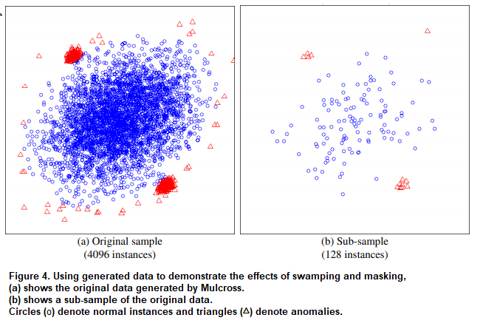
The data set has two anomaly clusters located close to one large cluster of normal points at the center. There are interfering normal points surrounding the anomaly clusters, and the anomaly clusters are denser than normal points in this sample of 4096 instances. Figure 4(b) shows a sub-sample of 128 instances of the original data. The anomalies clusters are clearly identifiable in the sub-sample. Those normal instances surrounding the two anomaly clusters have been cleared out, and the size of anomaly clusters becomes smaller which makes them easier to identify. When using the entire sample, iForest reports an AUC of 0.67. When using a sub-sampling size of 128, iForest achieves an AUC of 0.91.

- max_features: The number of features to draw from X to train each Tree.
Value of 1.0 is chosen, since it includes all features in training each Tree, and gave decent results.
- warm_start: When set to True, reuse the solution of the previous call to fit and add more estimators to the ensemble, otherwise, just fit a whole new forest.
chosen value is False since fit function is called once.
Later, the 10 features with the highest SHAP values were chosen to do the model training via StratifiedKFold:
Accuracy | Precision | Recall | F1-Score
93% | 97% | 95% | 96%

To analyze the errors in the detection I used the model from the last fold:
Since EventID identify the kind of task that was done, I firstly looked at EventID values.
FN:
When analyzing the distribution of errors, I found that around 90% of all false negatives involve EventID 7, and within those, 99% also share ThreadID 3292. This suggests that the model systematically fails on this log type. An explanation that can be is these feature values look very similar to normal events in the dataset, so the Isolation Forest considers them part of the normal cluster. In practice, this might mean that EventID 7 logs with this specific thread are frequent or “routine” enough to appear normal in the feature space, even if they are labeled anomalous. Thus, the model underestimates their abnormality.
FP (False alarms):
On the other hand, false positives occurred with 51% of EventID = 3 and within those 99% were Computer = 'WIN-J23NIGGP1Q6.sysmon_set.local' .
A possible explanation is that this specific combination of computer type with EventID is relatively rare in the dataset, so even though this particular instance was benign, the model interpreted the uncommon entry as a deviation from normal behavior.

XGBoost:
At its core, XGBoost builds a series of decision trees sequentially, each one correcting the errors of the previous one. This is achieved through the use of gradient boosting, where the algorithm focuses on the residuals (the differences between the actual and predicted values) in each iteration.
Just as in isolationForest I use GridSearchCV search function in scikit-learn to find the best parameters to train the model.
Hyper Parameters Tunning:
- objective: Changing this parameter affects the fundamental nature of the learning task. For regression, using reg: linear is appropriate. Other objectives like reg: logistic are used for classification. We will use reg: logistic as we do classification task.
- colsample_bytree: It’s the fraction of features (columns) used in each tree. It controls the randomness of feature selection at each split. Increasing this value can lead to overfitting as it allows more features to be considered at each split. Decreasing it can reduce overfitting but may increase bias.
This parameter was chosen in GridSearchCV from the values 0.5, 0.6, 0.7, 0.8, 0.9.
- learning_rate: This is the step size shrinkage used to prevent overfitting. It’s a factor by which the predictions of the current model are scaled before being added to the ensemble. Smaller values (e.g., 0.01) make the boosting process more conservative, but require more boosting rounds. Larger values (e.g., 0.3) can lead to overfitting. We will start with 0.001 as it is important for us to shrink overfitting, and during the process of parameters tunning this value kept good results.
- max_depth: It sets the maximum depth of each tree. Deeper trees can capture more complex relationships, but can also lead to overfitting. Increasing this value allows the trees to grow deeper, potentially capturing more complex relationships. However, it can also increase the risk of overfitting.
This parameter was chosen in GridSearchCV from the values 3, 5, 7, 9. And 9 was the best.
- gamma: Minimum loss reduction required to make a further partition on a leaf node of the tree. The larger gamma is, the more conservative the algorithm will be.
This parameter was chosen in GridSearchCV from the values 0, 0.1, 0.2, 0.3, 0.4. And 0.1 was the best.
- n_estimators: This is the number of boosting rounds (trees) in the ensemble. It controls the complexity of the model. Increasing the number of estimators allows the model to learn more complex relationships, but can also increase the risk of overfitting. However, adding too few trees may result in underfitting.
This parameter was chosen in GridSearchCV from the values 100-1000 with jumps of 100. 900 gave the best results.
- Scale_pos_weight - Control the balance of positive and negative weights, useful for unbalanced classes.

Finally, in the training and testing we did 10-stratified cross validation and we achieved the following results:
Accuracy | Precision | Recall | F1-Score
99% | 99% | 95% | 97%

To analyze the errors in the detection I used the model from the last fold:
FN:
false negatives occurred with 58% of EventID = 1 and within those 58% were Computer = 'WIN-J23NIGGP1Q6.sysmon_set.local' and 41% were Computer = 'WINDOWS10EVAL.stefania.local'.
A possible explanation is that this specific combination of computer type with EventID is relatively frequent and thus it is tagged as normal label.
FP:
Interestingly, false positives occurred with 51% of EventID = 1 and within those 91% were Computer = 'WIN-J23NIGGP1Q6.sysmon_set.local' and 9% were Computer = 'WINDOWS10EVAL.stefania.local', the same computers and EventID as in the FN. However, in FP cases ThredID values were centered : 39% for 1292, 28% for 3408 and 20% for 1912. In FN they were not dense around particular values, they were changing along the entries. This suggests that to model decision was more influenced by ThreadID.

Part 4: Comparing the results of the 3 AI models
 | Auto Encoder | IsolationForest | XGBoost
Accuracy | 99% | 93% | 99%

When looking at each of the AI method results, we see that AutoEncoder and XGBoost are the leaders, and IsolationForest is with lower result.
A possible explanation for it is that XGBoost is a supervised learning method, and it learns directly from labels and thus separates patterns more efficiently. However, AutoEncoders and IsolationForest are unsupervised learning and rely on the assumption that anomalies are rare, which is true in our case.
Still XGBoost gets information they don't get.
Let's analyze FP and FN in the AutoEncoder:
When analyzing the FP and FN something strange happened, in both the FP and FN arrays the most common values in the records were:
EventID = 3
Computer = 'LAPTOP-ROPR18AK'
ProcessId = 4.0
I turned to the Loss diagram:
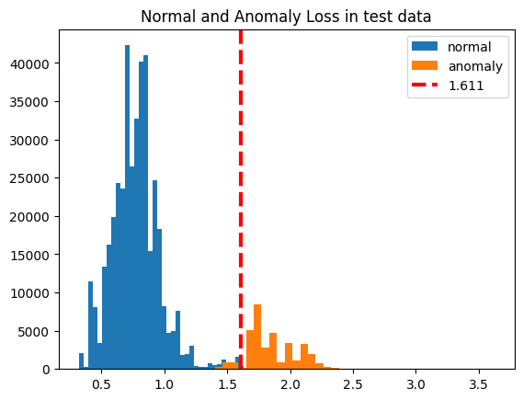

When looking at the diagram, we can see that the false positives fall within the same loss range as many true negatives and false negatives. The separation between false negatives and true positives is small. A possible explanation is that these feature values produce reconstruction errors that overlap with those of normal events. As a result, the Autoencoder struggles to discriminate between classes when encountering these values, leading to misclassification.
To summarize, we could not identify a single set of feature values that consistently led to false positives or false negatives across all models. Instead, each ML method struggled with different feature-value combinations, suggesting that the misclassifications are tied to the way each model learns and represents the data.

